

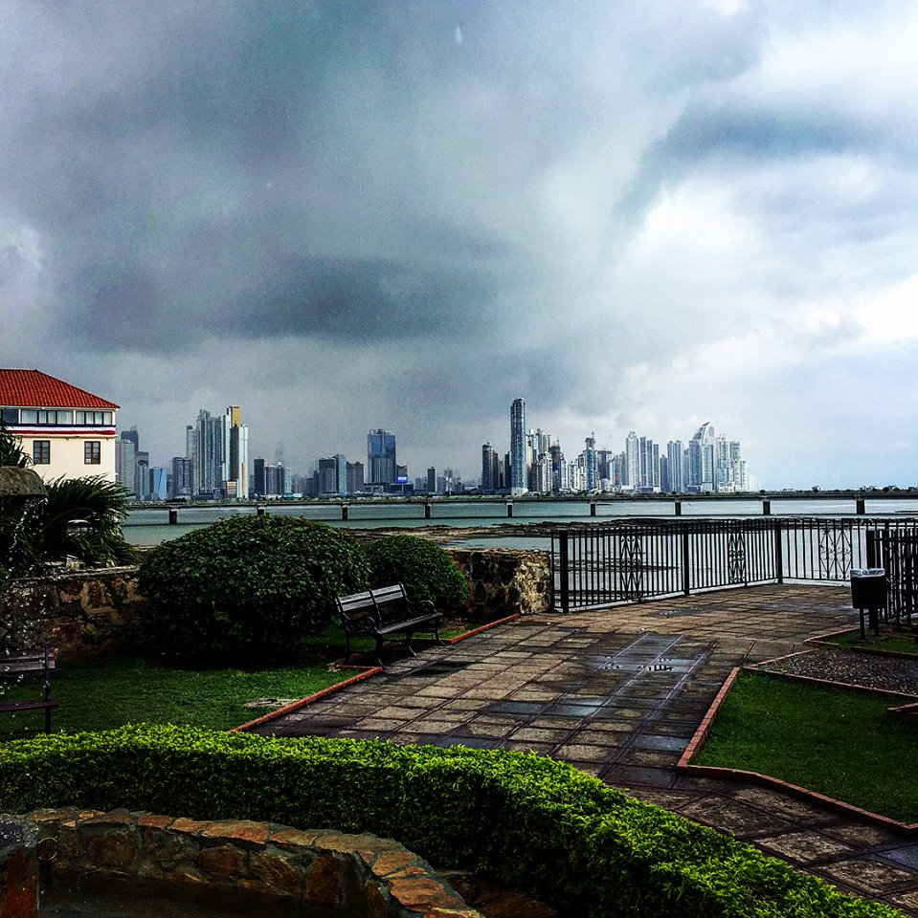

PANAMA MISSIONS TRIP

April 4-13, 2019

Scope of Project

Primarily block construction of Phase 4 of the Latin America Resource & Training Center (LARTC). This facility will serve educational ministries in the Spanish-speaking Latin America and Caribbean region by enabling leadership, training educators and providing resources. We will also have the opportunity to visit and interact with some local Child Hope schools that provide food, clothing, and education to needy children throughout Latin America and the Caribbean.

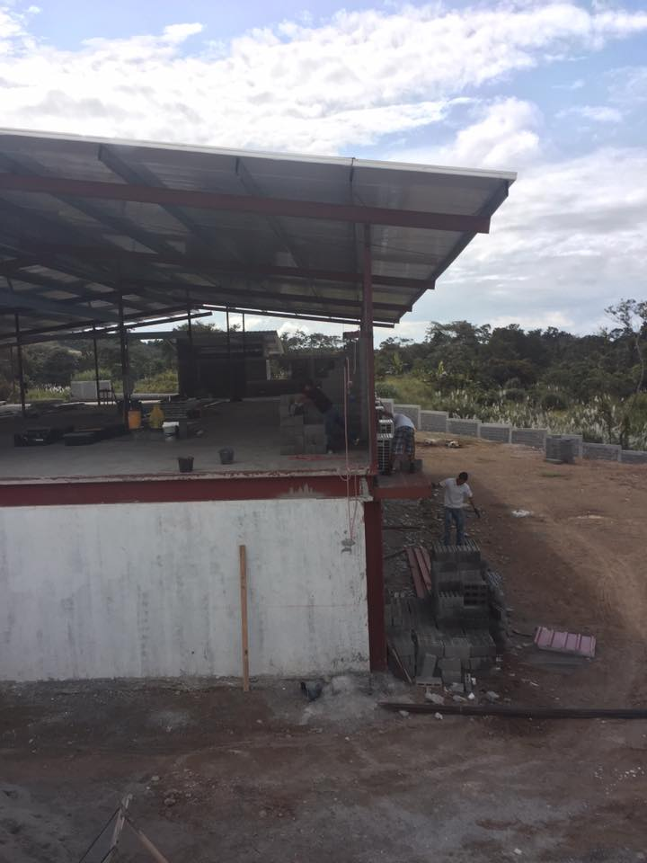

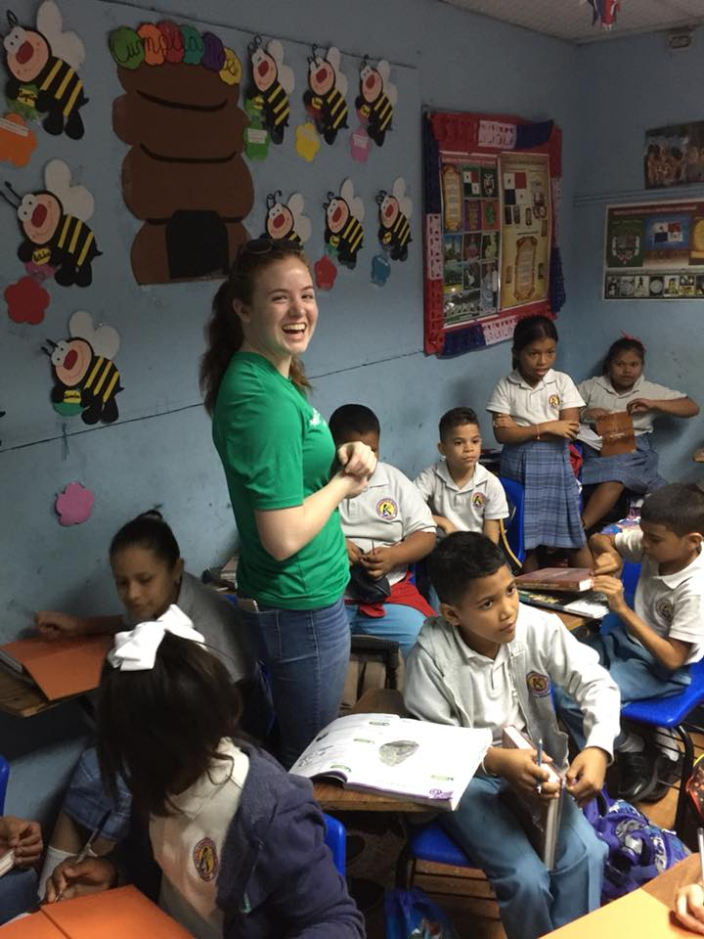 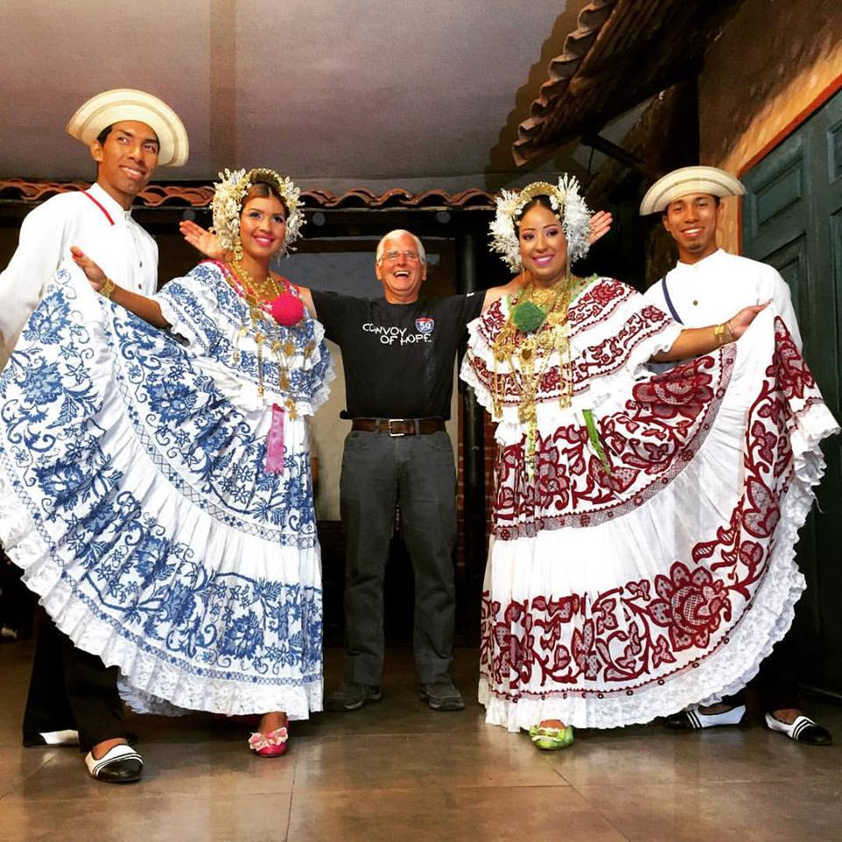

Cost of Trip

$2000 per person. This includes RT air travel and all in-country expenses while in Panama (housing, food, ground transportation, water, team shirts, entrance to the Panama Canal Visitor Center, and travel insurance). Any souvenirs, meals on flight days, and additional fun day activities are optional and not included in the cost of the trip.

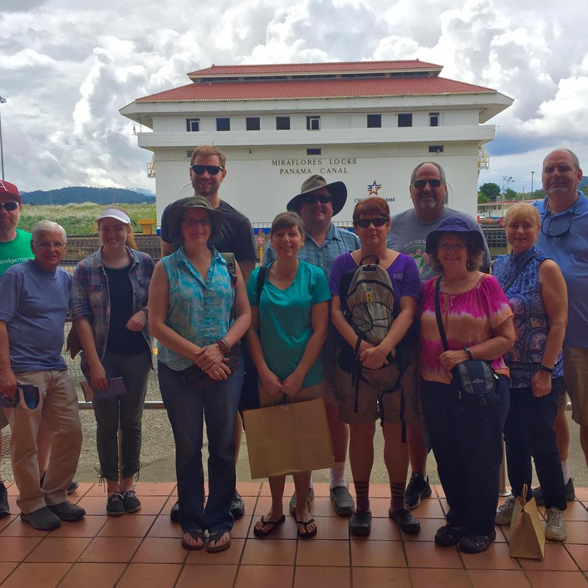

**Team Meetings & Payment Schedule**

* Sunday, January 20th (12:45-1:30 pm) in the Welcome Center

Topic: Trip Orientation and Fundraising

Application & $500 due

* Sunday, February 10th (12:45-1:45 pm) in the Welcome Center

Topic: Cultural Sensitivity & Travel Logistics

Second $500 due ($1000 total)

* Sunday, March 3rd (12:45-1:45 pm) in the Welcome Center

Topic: Ministry Preparation

Third $500 due ($1500 total)

* Sunday, March 31st (12:45-1:45 pm) in the Welcome Center

Topic: Safety, Health, and Departure Process

Third Payment Due: $500

* Wednesday, April 3rd (7:00-8:30 pm) in the Atrium

Topic: Final Trip Details/Weigh & Check Luggage

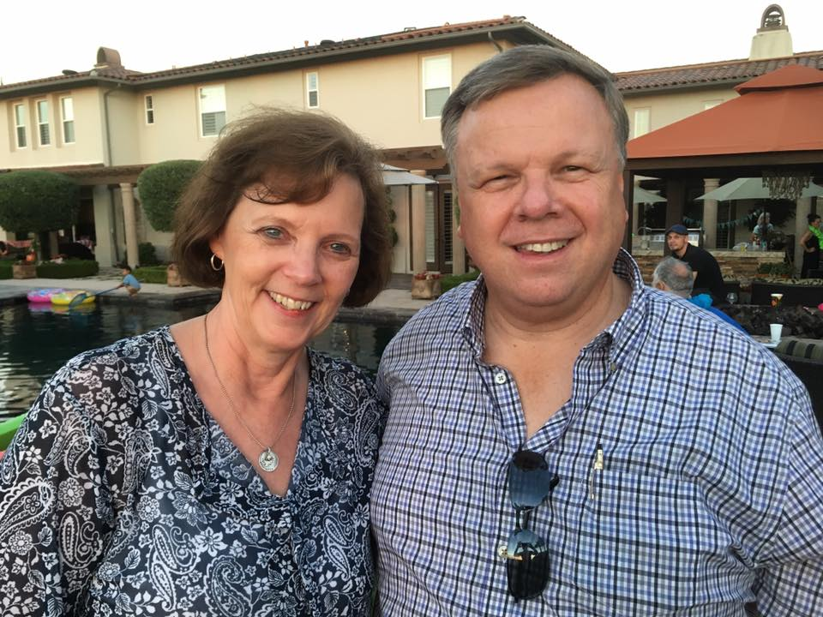

**Missionaries Rod & Sherry Boyd**