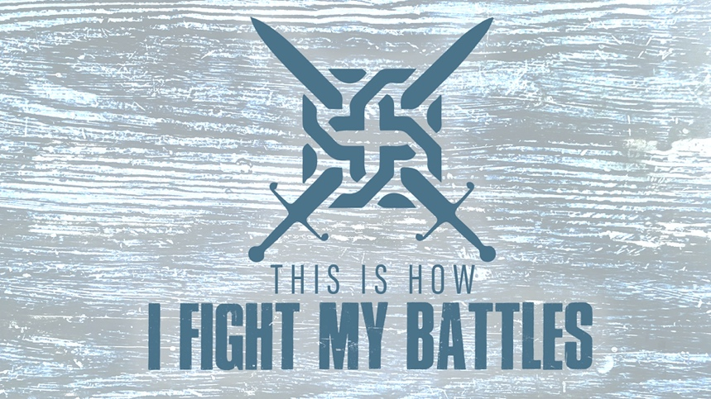

EASTRIDGE MEN’S ONLINE BIBLE STUDY
April 1, 2020

Week One: “Way Maker”
Exodus 13:17-14:31

GROUP DISCUSSION QUESTIONS

Getting Started (10 Minutes)

- What is your all-time favorite “war movie?” Why?

- What is one thing from this week’s teaching from Pastor Larry that spoke to you the most?

Digging Deeper (25 Minutes)

- It has been said that when we first become Christians and start our journey with Christ, we expect it to be like boarding a “cruise ship.” We soon discover, though, that we have boarded a “battle ship.” Why do you think that God allows and even directs us into battles?

- God often leads us in a “roundabout” way that doesn’t seem reasonable. Share with your group a time when God led you down a path that didn’t make sense at the time. Now looking back, what did you learn about God and about yourself during that time?

- Moses commanded the Israelites to “fear not…stand firm…and be silent” because God would work for them and fight for them. What do you find most difficult – not being afraid, standing firm, or being silent – when you are facing a battle?

- In Exodus 14:31 it tells us that the people of God “feared the Lord, and they believed in the Lord” after God had miraculously brought them through the Red Sea and defeated the Egyptians. Share with your group about a time when God made a way for you and helped you win a victory and how that affected your view of God as a result.

Wrapping Up (10 Minutes)

- Share a “battle” that you or someone you know is facing right now so that your group can pray with you.

- Pray for each other before closing your meeting

