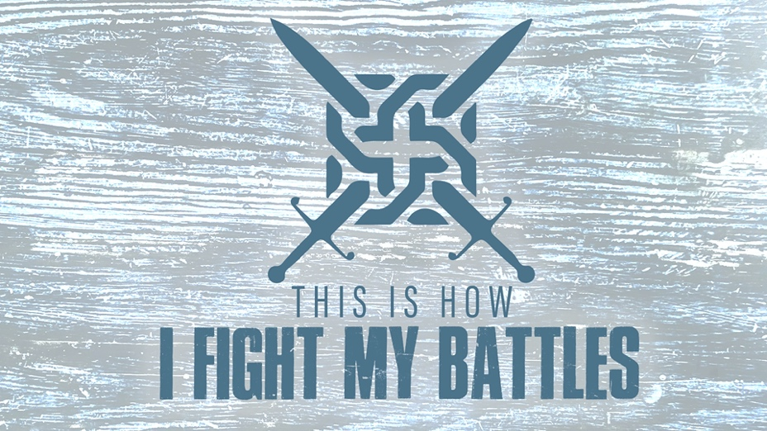

EASTRIDGE MEN’S ONLINE BIBLE STUDY
April 29, 2020

Week Five: “I’m Surrounded!”
2 Kings 6:15-17

TEACHING NOTES

When I’m Surrounded…

1. What I Don’t Do is More Important Than What I Do

2. What I Can’t See is More Important Than What I Can See

- Hebrews 11:1

- 2 Corinthians 4:16-18

- Psalm 121:1-3

- Ephesians 1:15-23

3. Praying For Perspective is More Important Than Praying for
Protection or Provision

- Don’t let something small block your vision of something big

- When God is factored into the equation, you are never outnumbered

- Whenever you feel surrounded, remember that God not only surrounds you, He surrounds what surrounds you.

