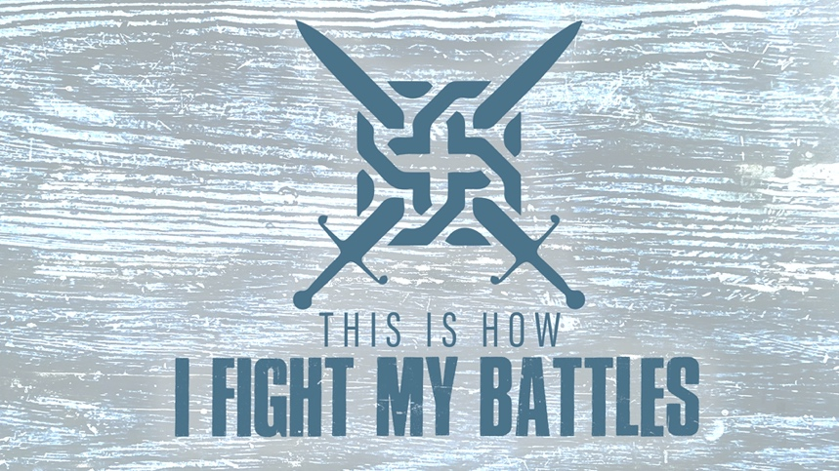

EASTRIDGE MEN’S ONLINE BIBLE STUDY
April 22, 2020

Week Four: “Lessons From Ziklag”
1 Samuel 30

GROUP DISCUSSION QUESTIONS

Getting Started (10 Minutes)

- What is the most valuable item you have lost or was stolen from you?

- What is one thing from this week’s teaching that spoke to you the most?

Digging Deeper (25 Minutes)

- From the following passages in the Psalms, how does David seem to strengthen himself in the Lord when things are going bad? What devotional exercises does he adopt? What is the focus of his faith?

Psalm 18:6
Psalm 27:1-2
Psalm 34:1-6
Psalm 40:1-3
Psalm 42:1-6
Psalm 56:1-4
Psalm 62:1-2

- Often times we seek the Lord more fervently in prayer when we are in great trouble and distress. Talk about a time in your life when you prayed with great fervency. What were the circumstances? What was the outcome?

- Compare Saul’s partial obedience in 1 Samuel 15 with David’s complete obedience in 1 Samuel 30. What was the outcome? How is David’s heart different than Saul’s?

- Even though David was experiencing the pain of loss, he still had compassion on others (the 200 exhausted men who stayed behind and the sick and dying Egyptian slave who had been abandoned by his Amalekite master). How do you think David was able to be so compassionate while he was personally experiencing pain and loss?

- This is a story of God bringing restoration and recovery in our lives. Share how God has restored you and brought back things into your life that the enemy has stolen from you.

Wrapping Up (10 Minutes)

- Are there some things that the enemy has stolen from you that you need God to restore? Share them with your fellow group members and pray together for God to bring back what the enemy has taken.

