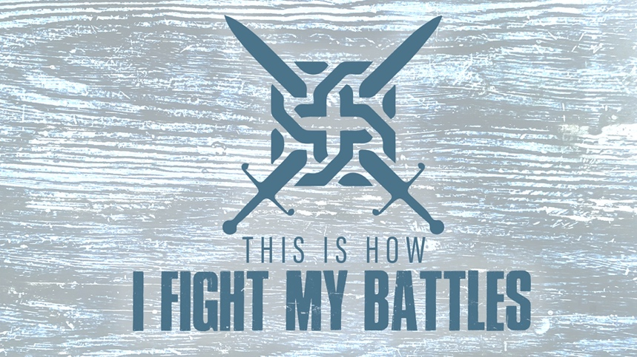

EASTRIDGE MEN’S ONLINE BIBLE STUDY
April 8, 2020

Week Two: “Receiving God’s Victory”
Joshua 6:1-20

GROUP DISCUSSION QUESTIONS

Getting Started (10 Minutes)

- Everybody loves it when “underdogs” win. Share a personal example of when you won a game when you were the underdog going in? If you don’t have a personal example, share an underdog story that has inspired you.

- What is one thing from this week’s teaching from Pastor Larry that spoke to you the most?

Digging Deeper (25 Minutes)

- Several times throughout God’s Word, when God speaks, the first word He says is “See” or “Behold.” Why do you think that is significant?

- The Israelites were all too familiar with “circling.” They circled and wandered in the wilderness for 40 years. Now they were to circle around the city of Jericho. Discuss the differences between circling in the wilderness and circling Jericho.

- Pastor Larry asked the question, “Does a stronghold have a strong hold on you?” Share with your group a stronghold that you currently are struggling with or have struggled with in the past.

- The “Ark of the Covenant” represented the presence of God and it was placed in the center between the front and rear guards. God is to be at the center of every part of our lives. Discuss how having God at the center of our relationships, our careers, our finances, our hobbies, etc. makes a difference.

- Have you (or are you currently) had to circle your Jericho for a long time? What have you learned from your experience and/or from today’s lesson that helps you to keep walking even when it seems there is no obvious progress?

Wrapping Up (10 Minutes)

- Remember that nobody faces a Jericho alone. “They” captured the city. It was a victory that the community of God’s people received. What is one practical way you can encourage each other this week?

- Pray for each other before closing your meeting

