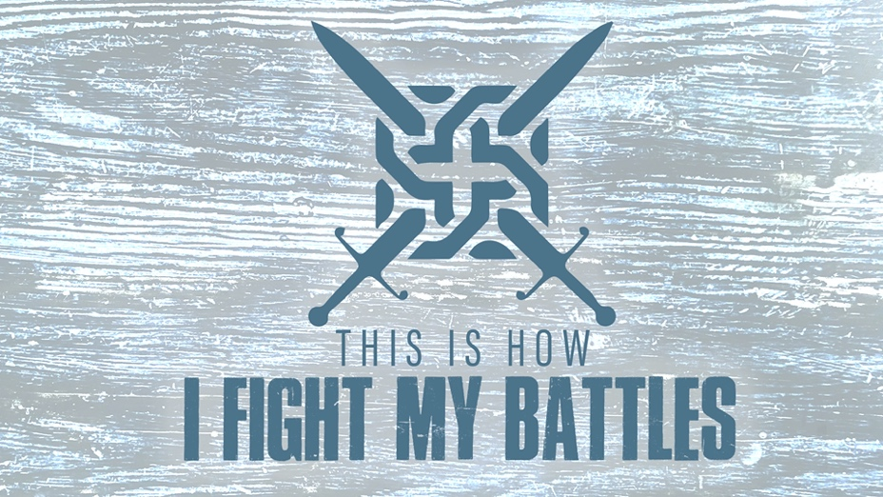

EASTRIDGE MEN’S ONLINE BIBLE STUDY
May 20, 2020

Week Eight: “Forward!”
1 Samuel 14:1-23

TEACHING NOTES

Psalm 18:29 (NIV) – “With your help, I can advance against a troop; with my God I can scale a wall.”

Background/Context

- Saul acted foolishly out of fear and disobeyed God’s clear command
- The people of God were hiding in caves from the enemy
- They had no weapons

1. Jonathan’s Audacity (1 Sam. 14:1,4-6)

- “Come, let us go…”

- Bold faith looks to advance against the enemy

- Bozez = “shiny” or “slippery”

- Seneh = “thorny” or “bramble bush”

2. Jonathan’s Secrecy (1 Sam. 14:1,3)

- Be careful who you tell what is in your heart

- A man with bold faith in God, never makes a big deal about his actions

3. Saul’s Inactivity (1 Sam. 14:2-3)

- “Staying”

- Faith has a price, but so does fear – which price will you pay?

- Be careful with who you surround yourself with

4. Jonathan’s Confidence Without Certainty (1 Sam. 14:6)

- “May be” or “perhaps”

- Faith in God allows us to dream of the possibilities even in the midst of uncertainties

- Faith in God allows us to move forward with confidence in God, trusting Him with the results

5. The Armor Bearer’s Loyalty (1 Sam. 14:7)

- An “Armor Bearer” played a vital and vulnerable role

6. Jonathan’s Strategy (1 Sam. 14:8-12)

7. God’s Victory (1 Sam. 14:13-15, 23)

