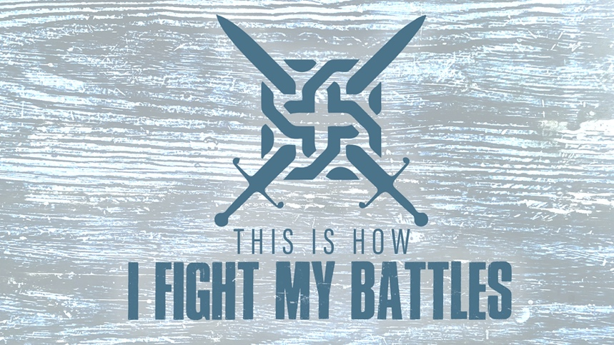

EASTRIDGE MEN’S ONLINE BIBLE STUDY
May 27, 2020

Week Nine: “Our Champion”
1 Samuel 17:1-11

GROUP DISCUSSION QUESTIONS

Getting Started (10 Minutes)

- As a child or teenager, who was your hero (sports, television, movies, or fictional character)? Why?

- Which of the eight battles we have covered has been your favorite? Why? (Crossing the Red Sea, Walls of Jericho, Gideon, David at Ziklag, Elisha and his servant, Hezekiah, Jehoshaphat, or Jonathan and his armor bearer)

Digging Deeper (25 Minutes)

- Two strategies of the enemy that are common are creating fear and discouragement through intimidation. Have you found this to be true in your life? What has been helpful in battling fear and discouragement for you?

- In all of the battles we have studied it has not been a case of strength vs. strength, but of weakness over strength. Read 2 Corinthians 12:9-10. Why is our weakness a prerequisite for receiving God’s power?

- Read 1 Samuel 17:32-37,45-47. What is the basis for David’s courage in facing Goliath? If you were to interview David after the battle would he say that he defeated Goliath because of his own strength and strategy or God’s? Why?

- In what ways is David’s victory over Goliath a foreshadowing of Jesus as our Champion?

Wrapping Up (10 Minutes)

- All of our fears have their roots in the ultimate fear of death. How has Jesus enabled us to not fear death? How should that change the way we approach life?

- Take time to pray for each other’s needs.

