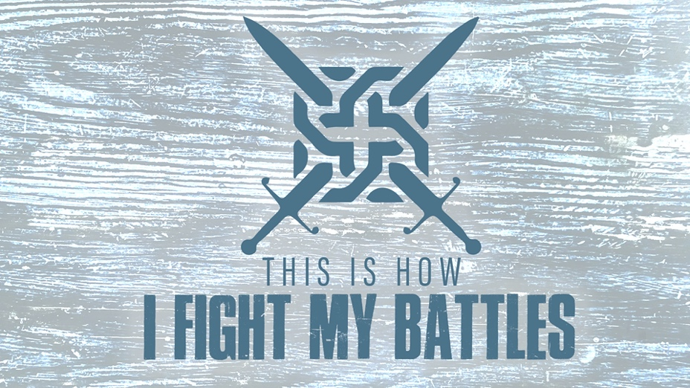

EASTRIDGE MEN’S ONLINE BIBLE STUDY
May 27, 2020

Week Nine: “Our Champion”
1 Samuel 17:1-11

TEACHING NOTES

Series Review

- Our enemy (Ephesians 6:10-12)

- Our weakness (2 Corinthians 12:9-10)

- Our weapons (2 Corinthians 10:3-4)

- Our help (Psalm 121:1-2)

Our Champion

Three Levels of Understanding Old Testament Narrative…

1. The Personal Level

2. The National Level

3. The Redemptive Level

David and Goliath (1 Samuel 17)

- The battle lines are drawn (17:1-3)

- Goliath is described (17:4-7)

- Goliath taunts and defies Israel (17:8-11)

- A champion steps forward (17:12)

Conclusion

- Romans 8:31-39

- John 11:25-26

