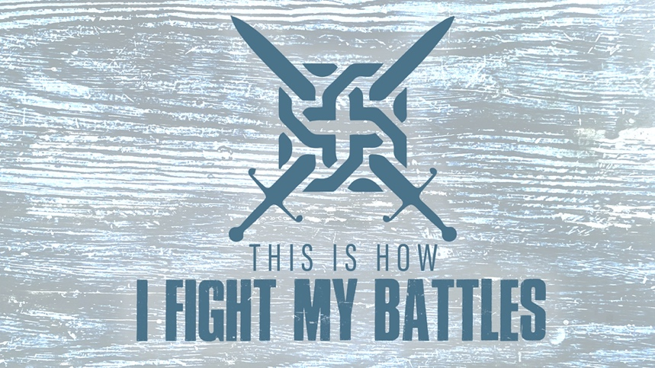

EASTRIDGE MEN’S ONLINE BIBLE STUDY
May 13, 2020

Week Seven: “Ambushed!”
2 Chronicles 20:1-30

GROUP DISCUSSION QUESTIONS

Getting Started (10 Minutes)

- Do you like surprises? Why or why not? Describe the best (or worst) surprise you have ever experienced.

- What is one thing from this week’s teaching that spoke to you the most?

Digging Deeper (25 Minutes)

- In 2 Chronicles 20:3, it says that when Jehoshaphat was afraid, he “set his face to seek the Lord.” Is that your initial resolve when you are afraid? If not, what other responses tend to be your first reaction? If so, how have you developed that resolve to seek the Lord when you are afraid?

- Review Jehoshaphat’s prayer in 2 Chronicles 20:6-12. What elements of his prayer (refocusing on God’s power, recalling God’s past victories and future promises, recognizing your weakness and asking for His help) do you think you need to include more in your prayer life when faced with difficult circumstances?

- Jehoshaphat closed his prayer with these words: “We do not know what to do, but our eyes are on you.” Do you find it hard to admit that you are weak or don’t know what to do? Why is admitting our weakness and asking God for help important?

- Have you ever used worship as a weapon against your enemy? How have you found praise and worship of the Lord to be helpful to you in fighting your battles?

Wrapping Up (10 Minutes)

- The valley where the Lord brought about victory for Judah and Jehoshaphat was named the “Valley of Beracah” or “Valley of Blessing.” Share with the group a time in your past where the Lord has turned a battle into a blessing in your life.

- Take time to pray for each other’s needs.

