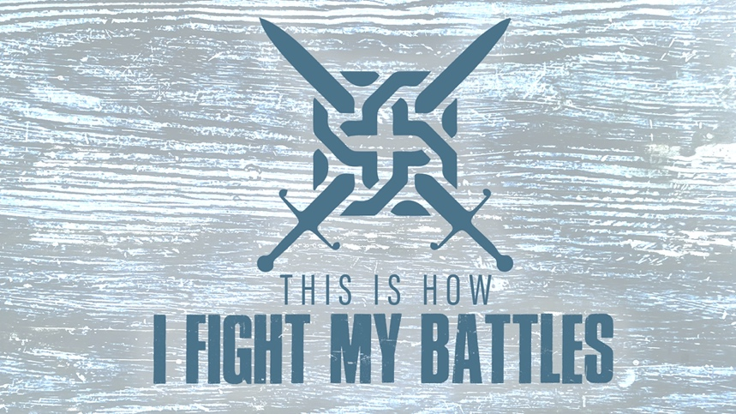

EASTRIDGE MEN’S ONLINE BIBLE STUDY
May 6, 2020

Week Six: “Resisting the Enemy”
2 Chronicles 32:1-23

GROUP DISCUSSION QUESTIONS

Getting Started (10 Minutes)

- In sports we have archrivals – those “enemies” that we love to hate and love even more to defeat. Share with the group a memory you have of you or your favorite team defeating your archrival.

- What is one thing from this week’s teaching that spoke to you the most?

Digging Deeper (25 Minutes)

- Because Hezekiah chose to live and rule righteously before God, he experienced fierce opposition from Assyria. Where do you experience the most opposition, ridicule, and resistance as a follower of Jesus? Work? Home? Government? Your own mind? Extended family? Unsaved friends/family? Other?

- One of the weapons we have to resist the enemy is the Word of God. Read the following passages and discuss how God’s Word is effective in spiritual warfare

Matthew 4:1-11
Romans 15:4
2 Timothy 3:12-17

- Hezekiah prepared for the battle with Sennacharib by planning and praying. Why are both planning and preparing important? Which do you find comes more naturally for you to do?

- Read Hezekiah’s prayer in 2 Kings 19:15-19. What does he say about God that helps you trust in Him when you are facing opposition from the enemy?

Wrapping Up (10 Minutes)

- Hezekiah sought out the prophet Isaiah as a partner in prayer. Who has been a prayer partner for you during times of trials, testing and opposition? How has that partnership helped you in resisting the enemy?

- Take time to pray for each other’s needs. Pray that God in His greatness would answer in a way that brings Him the most glory in each situation.

